Module 11 – EOQ

Exploratory Data Analysis

*In this section, you should perform some data analysis on the data provided to you. Please format your findings in a visually pleasing way and please be sure to include these cuts:*

* *Make line graphs showing the following data over time:*
  + A graph showing a line

    AI-generated content may be incorrect.
* *Use a forecast method to determine annual demand for 2025 to use for our model*
  + *Naïve*

*Forecast for 2025 = 2024 actual which is 15516*

* *For costs, use a similar/different method. Otherwise, a simple overall average is fine.*

*Naïve Forecast of AVG Cost for 2025 = 213.18*

Model Formulation

*Write the formulation of the model into here prior to implementing it in your Excel model. Be explicit with the definition of the decision variables, objective function, and constraints. Please restate the variables in the algorithm (i.e. D = Annual Demand)*

Q > 0

Model Optimized for Minimizing Costs with Optimal Order Quantity

*Implement your formulation into Excel and be sure to make it neat. This section should include:*

* *A screenshot of your optimized final model (formatted nicely, of course)*

**

* *A text explanation of what your model is recommending*

*Ordering 409.7 units per order is the most efficient and will minimize your overall inventory management costs based on your current demand, unit cost, ordering cost, and holding rate.*

* *Make a “sawtooth chart” for 2025, see below for reference. Assume you start with year with your EOQ Quantity like it has below*

*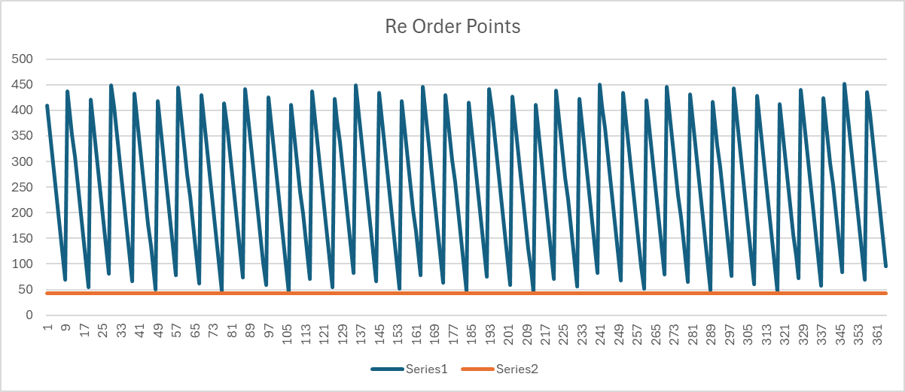*

Model with Stipulation

*Please copy the tab of your original model before continuing with the next part to avoid messing up your original solution.*

*Implement the below EOQ extension, EOQ with planned backorders. We have added 2 new variables: A = shortage cost & b = planned back orders. Restate the previous variables with these new ones please. Note, you’ll need to solve for both Q\* and b\* here to get the optimal solution. You should start Q out as the EOQ from the previous section and b as 0. Also, note that this algorithm does not include `D \* C` as it’s not relevant to this analysis*

**

*Lastly, do the following:*

*By including back orders, the business can fulfill future orders in a periodic manner. Thus,*

*customer satisfaction will be maintained even if inventory is out of stock. As a result, businesses can ensure that sales are not while customers are waiting or lost to competition.*

*Through this principle, businesses can offer flexibility and reliability in knowing when they*

*will periodically have shipment orders coming in. Additionally, it adds an element of*

*efficiency to the inventory on hand but avoiding overstocking shelves or distribution*

*centers. Thus, the amount of money spent on space occupied by the product(s) will be*

*minimized. Furthermore, product demand can become easier to track. Thus, the practices*

*of future forecasting and planning will be optimized. Overall, the inclusion of back orders*

*provides operational flexibility. This is done through optimizing production scheduling and*

*preventing rushed or disruptive adjustments in shipping practices to meet sudden demand*

*spikes or valleys.*